Tips to score marks in practical subjects + presentation + speed

How to Present Practical papers
1. Most of the Students loss there marks due to-
(i) After completing the 1st part of the answer, he directly goes to the next part without
properly specify or showing that one part is completed.
(ii) On second part, student is not specifying what he is calculating. He simply start his
calculation, how a examiner or a lay man can understand what you are doing with
below amounts. Properly give a short heading to your calculation.
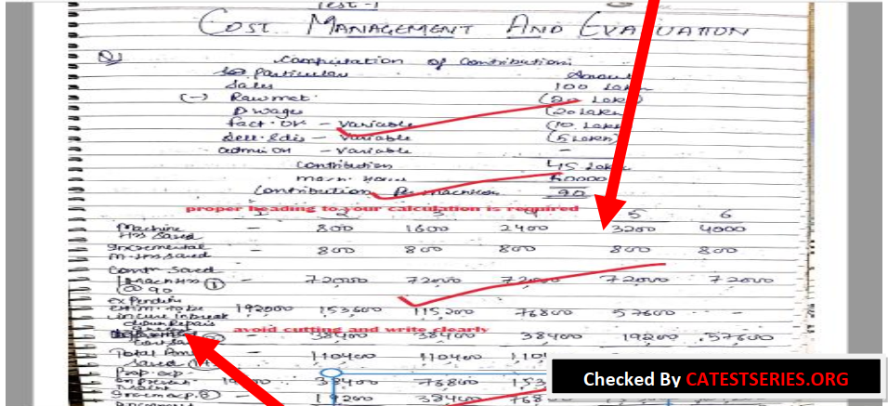
You should write neatly, Proper spacing is must.

2. Here the student is writing the observation or decision from the situation but he is skipping to write about the situation or option, he is only mentioning the option number. Proper mention the name of the option and reason. Proper reason is must otherwise you may lose 1 or 1.5 marks depending on the weightage.
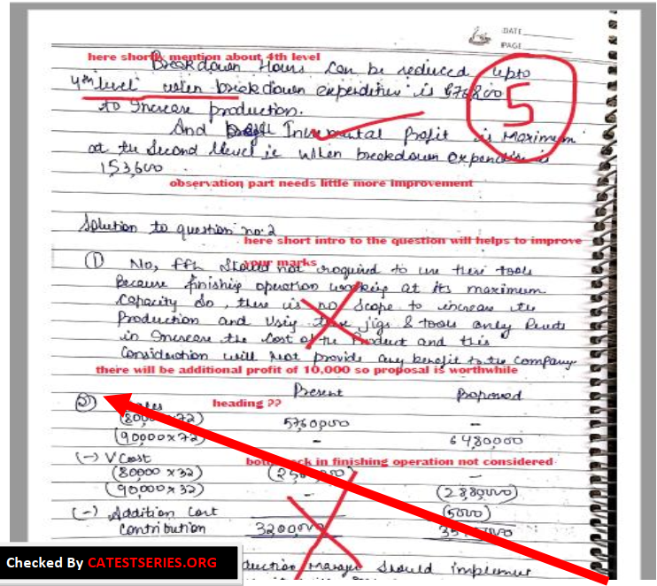

3. In Solution 2, question has asked about 6 situations. Student directly starts his answer from part 1, without giving any introduction. Also he is not specifying about the part that what it is about. He directly starts his calculation. Shortly mention that this part is about 9,00,000 proposed production of goods in next year or like that. You can also underline or highlight that heading. It will not take much time. No need to use different color pens, use one pen only.
4. In subjects like costing, Accounting, (SFM), decision making is quite important. Many students able to calculate the correct figures but didn’t got the correct conclusion due to lack of concept clarity in decision making questions.
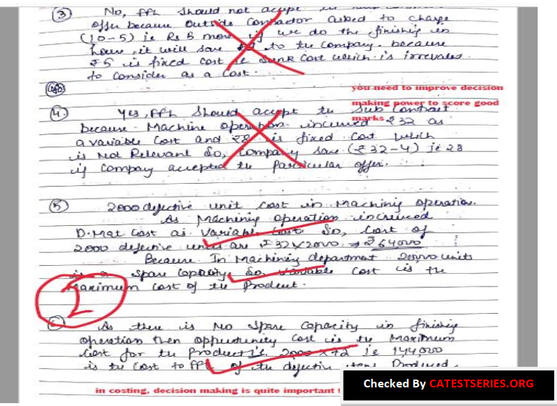

5. Write question number and other words clearly. Don’t overwrite. Examiner doesn’t have enough time to analysis and check what you are trying to write. Like in below question, student has attempted 4 questions, thereafter he has attempted 6th question but he over write the question number. Sometime it looks like he is trying to write question 5
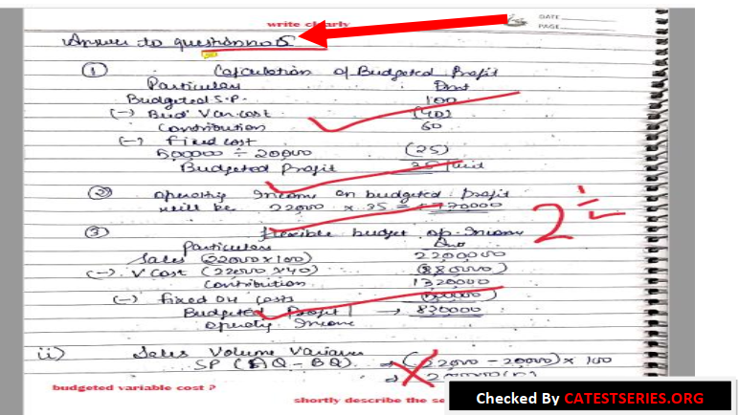

6. When you are writing numeric figures, must mention about the format of those figures whether it is in lac, thousands, crores or in units. This is must; many students lose marks over this point. Sometime due to this small mistake, they wrongly answered the question.
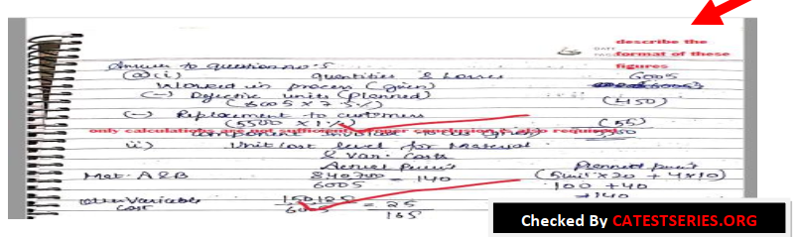
7. Although its not possible to write formula’s. But this student used intelligent approach. In small questions, he mentioned formula for main answer only. He didn’t write formula for working notes. It will save your time also and helps to score good marks.
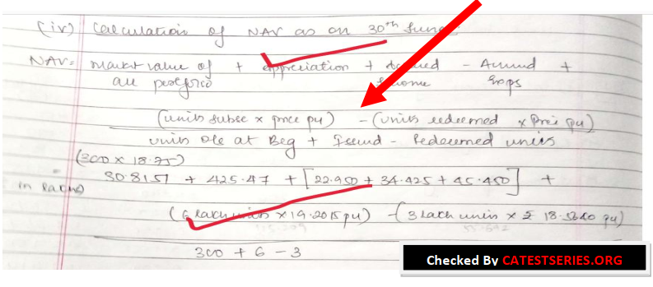
8. One of the important point about presentation is appropriate heading to your accounts or
statements is must. Like for balance sheet, value added statement, profit and loss etc, You have to mention date on which the statement is prepared and name of the company for which you are preparing the statement. These two things is must.
In case of journal entries, properly mention in whose books you are posting those journal entries. Another point is proper format of statements is must. Like in balance sheet properly categorize or sub-categorize the items
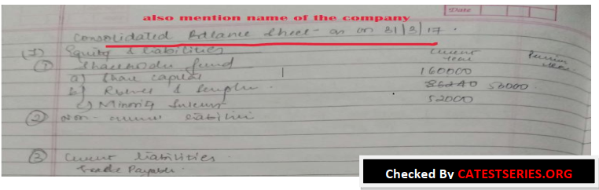

9. You presentations first look describe about your confidence. You can see the below two images. Your mind will make one thought, one looks like a student write with full confidence that he knows the answer and other one looks like a student is struggling to find the correct answer. This look also impact examiners mind. In your solutions looks confidence then you can expect more marks.
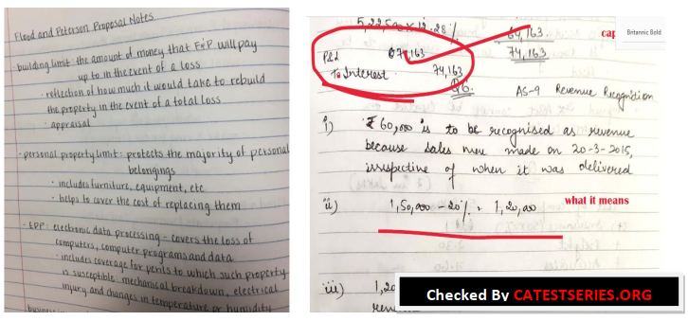

Speed
In most of the cases students knows 70–80% of the concepts but due to slow speed they can’t able to complete their exams in 3 hours.
So, for improving your speed in exam you have to keep followings facts in your mind:
Always try to write answer to question 1 and 7 in the beginning, as they are short 4–5 mark question, which you can complete within the 45 minutes to an hour and grab some easy 20–25 marks.
Next try to attempt the questions which are of 8 or 10 marks depending upon how well you know that question. Make sure you don’t take more then 10–15 minutes on every part, so that you have ample time in the end for the 16 marks question.
Into the final hour we need to complete 2 questions, they could either be 16 marks each or any other combination. Try to complete that questions in ascending order here too and make sure you don’t end up spending more then 25 minutes on each question.
100 marks ICAI exam paper and you have three hours in hand means 180 minutes so by that means I can say one point eight minutes per mark. So, let’s say we have a question often 10 mark so by that calculation you have 18 minutes in hand.
Do not take eighteen minutes rather take sixteen minutes what you need to do is you need to try to complete a question within these 16 minutes and treat these two minutes as buffer time as grace time. If you are unable to do your question in these 16 minutes, we shall utilize this time which we have capped aside 2-minute time buffer time or grace time and you shall utilize this time.
But, do not go beyond 18 minutes. Leave that question then and there itself, right P.T.O. at the bottom of the page and leave two or three pages so that in the case at the end of paper you have some spare time you can definitely invest that time on this question.

Sometime over-thinking consumes lot of time in exams, avoid considering the possibilities. No need to make-up the working notes part, only heading of notes should be clear. Shortly picturize the steps of solution in your mind and quickly start attempting. You may first make a short working note of questions information to get hold on information. Sometime doubtful mind may also leads to lose of time. Donot feel unrest while attempting the exam.

As we analyzed in students exams, sometime they donot understand the questions requirement and solve unnecessary parts also which they know very well. Reality is examiner donot drop his attention to that part. Examiner is very clear about what question is asked so he will look at questions required part quickly. If you attempt smarty then you will clearly answer those points in starting only.

Donot look at solutions directly while practicing at home, first analyze the question and think about all calculation. Attempt some calculations using calculator only, this will help to gain confidence. While attempting questions, be little bit conceptually attentive. Continuously brainstorm whether the figures are going in conceptually correct direction. In some subjects this is possible like in SFM , FR, Accounts etc.

How to Tackle with Practical Papers

As per the past 2 years trend of ICAI Exams, it was analyzed that those students who are attempts more number of questions rather than reading the summary or notes content again and again in last 1 month. Focus on more number of questions; try to give 80% of your study time to solve questions only in last 1 month.

There is no alternate to increase speed then by improving through attempting more number of questions.

