How to present theory answer in exams + speed + presentation + language + length of answer

How to present theory answer in exams
Good presentation doesn’t mean that you need to write slowly, designing the text and using
different types of pen. Stay away from illusations. Learn about the common errors which students commit in presentation. Good presentation can help to increase 10-12 marks in each exam.
Always start your answer with a proper sequence like
In the first para, Write the provision from the Act, and quote the section number or reference to the act.
In Second Para, Explain the Provision written in First Para.
In Third, Explain how your answer is related to the question given.
In Fourth Para, give a conclusion to the question.

If you don't remember the section exactly or you are in confusion don't mention the section. Mention 'as per the provisions of act'. No exceptions in remembering the title of the act and the year you should mention the same.
Writing the correct answer you have to present it properly. The answer must be given in a sequence as demanded by ICAI Law is not something that you can cram. It is reason based, there are reasons why a certain law was made and why it has such clauses. To study law, you must read it from the point of view of a thief.
Write to the point answer in exam. The examiner will figure out in a minute whether you have the knowledge or you are just filling pages to increase the quantity
Conclusion: After providing all the detail, you can conclude the answer by giving the crux of the above detail or taking up one side of coin (yes/no) if question ask your opinion.
Try to use technical words everywhere That gives good impression on evaluator
In exam never use short forms like AGM, EGM, CG, CLB, ROC, ICSI, ICAI, SAP, AS Etc
In below image, content is less but the student has opted paragraph format which looks awakward. And we cannot suitably compare both the options.
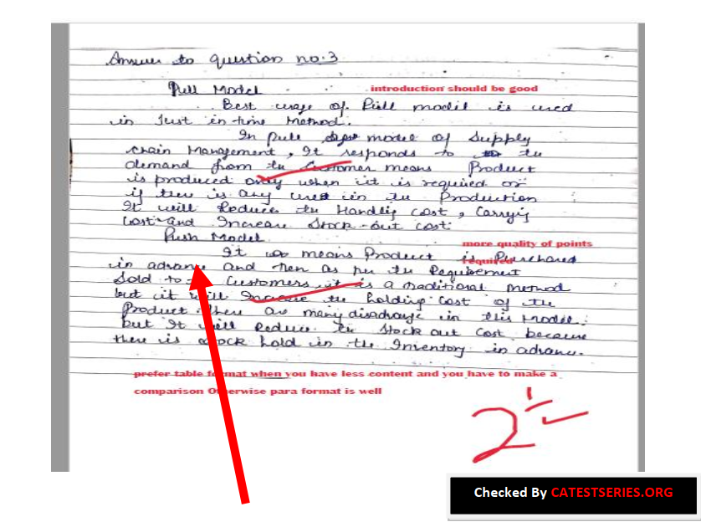
Here student is starting the second part of the question. No spacing leaves after completing first part.
Properly leave appropriate space after first part. So that a user can properly differentiate between
both and it should look good.
Write the question number at the centre of the page and not at the corner which is not clearly visible. Write all the sub-parts of a single question together. You may change the order as per your convenience. Prefer writing each sub-part on a new page so that in case you want to modify your answer later on, you can do it in the space you have left below each answer and it also looks presentable.
In paper like ISCA /ITSM/ EIS-SM you should always try to write answers in points because entire ISCA is point based and for every question there’s a certain set of points which you are expected to write.
In audit 2 to 3 short paragraphs consisting of 4 to 5 short sentences each will be a better presentation rather than writing one full page answer in just one paragraph which makes it look difficult for the examiner to read.

Speed
Many students have misconception that their SLOW WRITING SPEED is almost impossible to increase. While attempting the Theory paper in CA Final or CA Inter; almost every student finds it tough to COMPLETE the paper. Divide your paper in parts and solve accordingly
100 marks ICAI exam paper and you have three hours in hand means 180 minutes so by that means I can say one point eight minutes per mark. So, let’s say we have a question often 10 marks so by that calculation you have 18 minutes in hand.
Do not take eighteen minutes rather take sixteen minutes what you need to do is you need to try to complete a question within these 16 minutes and treat these two minutes as buffer time as grace time. If you are unable to do your question in these 16 minutes, we shall utilize this time which we have capped aside 2-minute time buffer time or grace time and you shall utilize this time.
Always try to write answer to question 1 and 7 in the beginning, as they are short 4 - 5 mark question, which you can complete within the 45 minutes to an hour and grab some easy 20 – 25 marks.
Next try to attempt the questions which are of 8 or 10 marks depending upon how well you know that question. Make sure you don't take more then 10 - 15 minutes on every part, so that you have ample time in the end for the 16 marks question.
Into the final hour we need to complete 2 questions, they could either be 16 marks each or any
other combination. Try to complete that questions in ascending order here too and make sure you don't end up spending more then 25 minutes on each question.
Write clearly, precisely and patiently without jumping to next question while attempting the
current one

Language

You can use your language but the keywords in the answers should not be replaced Read the law thoroughly. Law is not something that you can cram. It is reason based, there are reasons why a certain law was made and why it has such clauses. To study law, you must read it from the point of view of a thief.
Most examiners judge the quality of student’s language by the beginning 2-3 lines and conclusion part. There are some specific wordings in law and audit to write in starting and concluding the answer.
In the conclusion para you need to write your views/opinion like : " considering the provision contained in companies act as already stated above ABC Pvt Ltd should do/shouldn't do so and so" along with short reason.
Write to the point answer in exam. The examiner will figure out in a minute whether you have the knowledge or you are just filling pages to increase the quantity.
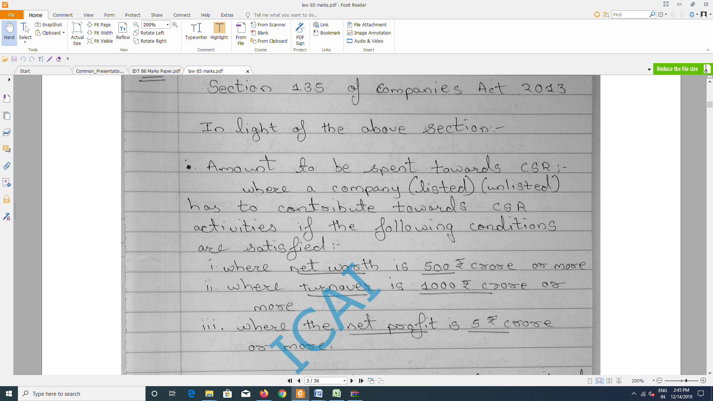
Key words in ISCA/ITSM/EISM play big role. You need to highlight the key words in your answer to gain checker’s attention. Don’t add more then required key words or it will be ruin answer. Key it’s short and sweet.
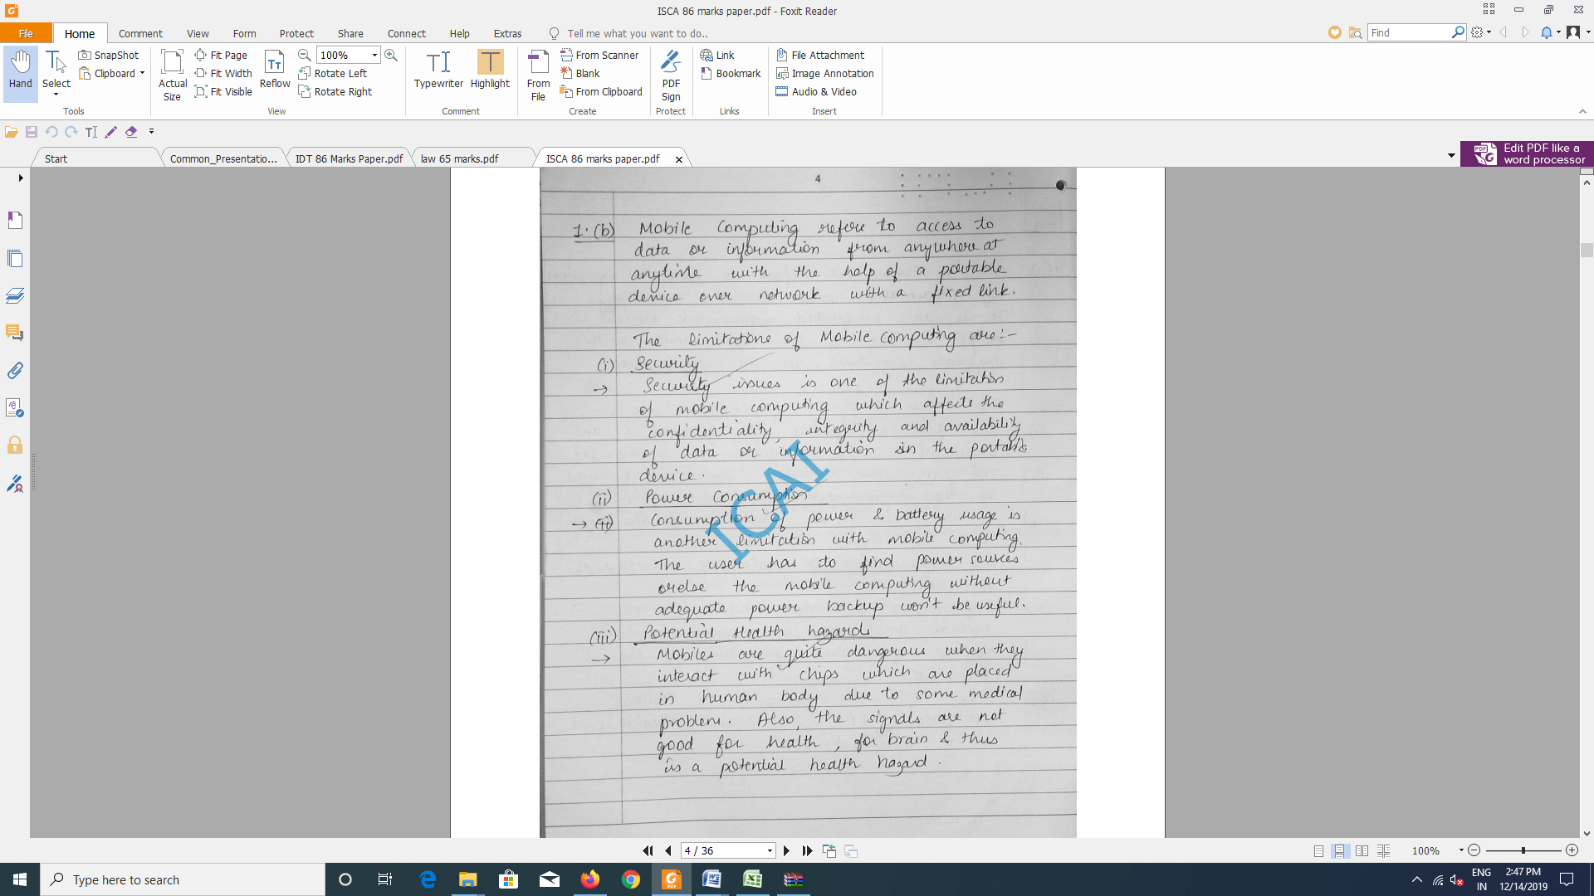

length of answer
Try to give answer short and accurate as much as possible. It’s not that if you will write it lengthy then your answer will be good. No. It should be not more than 2 pages or according to the question requirement. Divide your answer in paragraphs and headings or bullets, according to your question’s requirement.
Regarding this you may take reference from suggested answers provided by ICAI. Or Write your answer according to the marks allocated. You just needs to focus on Quality of content and some basic tips like Be precise and to the point rather than writing lengthy answers You need to understand questions requirement properly, and write your answer is demanded in the question try to avoid unnecessary points in exams.
Wherever you start next point, give one line gap to show checker where the points started and where it ends. This trick will be beneficial if your handwriting is not that good. Your way of presentation affects your marks.

