How to approach to case study type questions + MCQ's
How to solve case study based Question

Not only answer but case law should also be presented properly. Well, most of the students commit such a mistake. They write the name and directly give the result of case law.
However, You should summarize it with the fact of the case then explain the situation or problem in the case. At last, write the solution or result of the case. This presentation will help examiner in evaluating your paper easily and help you in attaining good marks.

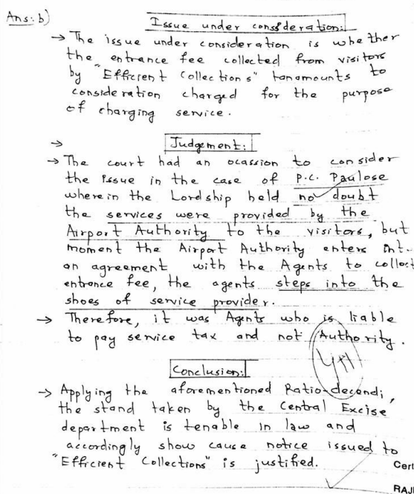

How to approach to MCQ's
From the above, the readers can understand that partially based objective is applicable for theory subjects (law/audit /Information system strategic management) and partially theory subject (taxation a dynamic, core, and amendment based subject). It will be in the nature of 1 or 2 marks. This is a 30 mark section for which there is no choice (internal/external).

1. Scan the paper 1st & solve the easies Question first. Rather than starting with a tough question that consume our more time and reduce confidence level
2. Read each question twice & check the options twice once you solve the problem
3. Don’t directly jump on to the option unless needed
4. Check your answer after doing 10-15 Questions & marks them in the OMR. Don’t wait till the end to revise
After attempting 10-15 Question Recheck the question once don’t mark directly if you are revise or rechecked at the end that is not valuable and waste of time and you does not able to change your answer. That trick reduce the chance of mistakes in OMR sheets
5. If you don’t have any idea about the Question and then you may go for guessing

Some basic tricks you also remember at the time of attempting MCQs

1. There is no explanation required only option is required

2. ICAI will try to confuse you by giving reasons for wrong answers which were correct but not asked in the question don’t fall for it.

3. Attempt MCQs before subjective Questions and aim to complete the MCQs under 30-45 minutes. Do rough work at the end of the answer sheet

